**Lihong Wang, lw324**

**Stage 1.1:** FFB

**Reflection:** Pretty straight forward.

**Stage 1.2:** FFLF FLFF B

**Reflection:** Had one less F before B on first try, got it second try.

**Stage 1.3:** JRJR JB

**Reflection:** No difficulties here.

**Stage 1.4:** FFLJ JJJB

**Reflection:** Took the most direct route near the edge of the map.

**Stage 1.5:** BJFL FBJL FFB

**Reflection:** Forgot to move forward after jump on first try, got it second try.

**Stage 1.6:** JLFJ BLFF RJFB

**Reflection:** Took two tries because I forgot what’s left and what’s right.

**Stage 1.7:** FLJB JBLJ BLJB

**Reflection:** I surprisingly got this one right the first time

**Stage 1.8:** JJRF LJBL FBJB

**Reflection:** Forgot to move first time, got it second try.

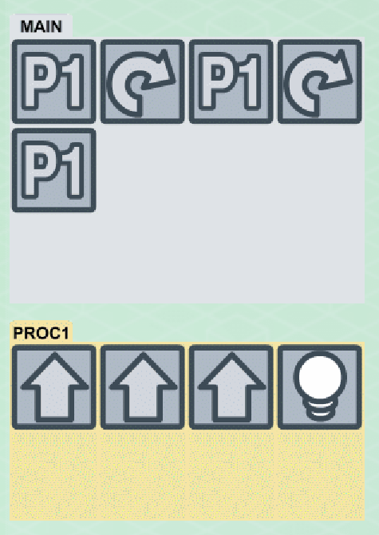Stage 2.1 Reflection: Straight forward, got it first try.

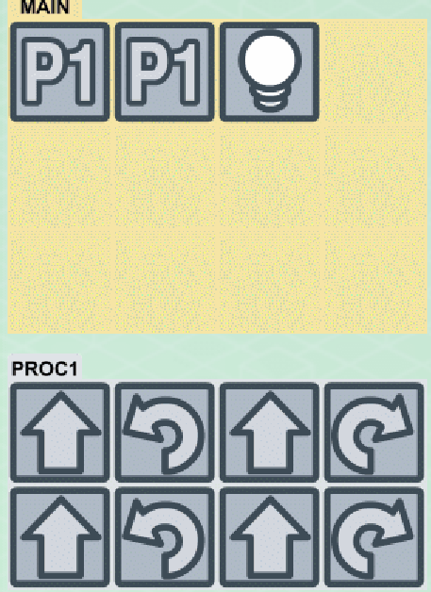

Stage 2.2 Reflection: Took a few tries since keeping track of the number of turns and moves posed a mental challenge in the absence of paper. But still got there in less than a minute.

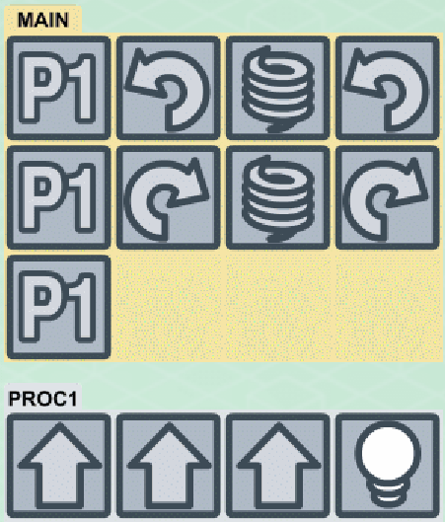

Stage 2.3 Reflection: I’d say this was easier than the last one, got it first try.